WEEK 1: CUSTOMER DATABASE MODULE

Requirement Analysis
An e-commerce system manages customer and product-related information. In this week, the customer database requirements were identified and implemented using SQL.

Customer Table Creation
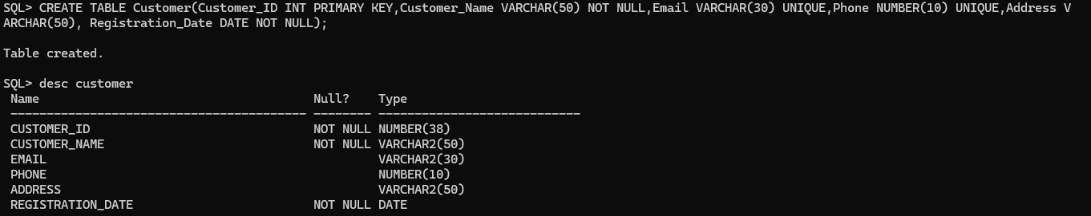
The customer table is created to store customer ID, name, email, phone number and created date.

Insert Customer Records
Customer details were added to the table using the INSERT command.

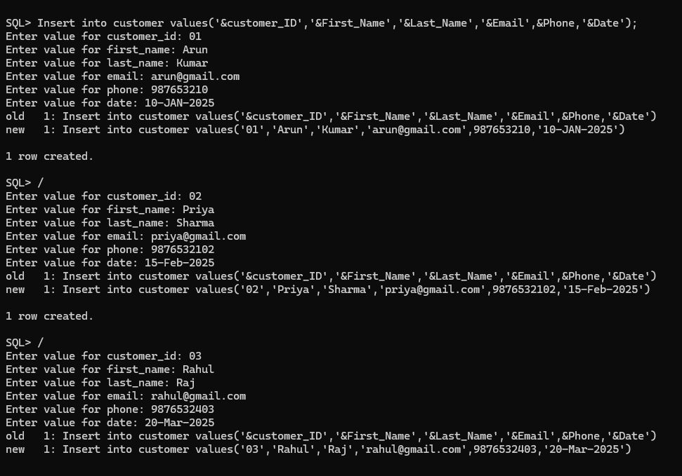

Display Customer Records
The SELECT command was used to display the records stored in the customer table.

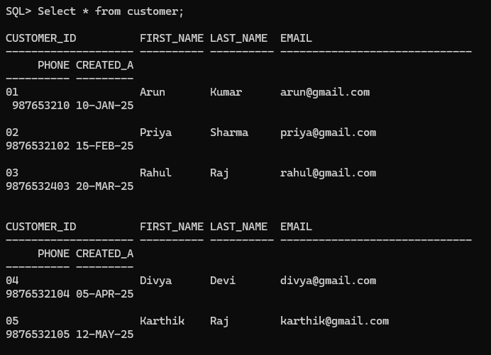

Update Customer Record
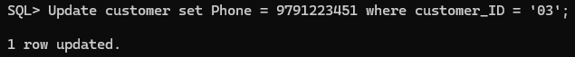
The UPDATE command was used to modify the phone number of customer ID 03.

The customer table was successfully created. Customer records were inserted, displayed and updated using SQL commands.

